Clues
Route Pubs
1 | Building for boxes of bygone brew
 | Found in decree Churchill issued
2 | Snooty Archer and King? Perhaps…
 | 150 are following holy chap
3 | Neither Mimi nor Iestyn has caught
 | I’m nosier sort
4 | A palpable hit with leafy plant
 | Kate’s given a religious slant
5 | His expectations were great for watering hole
 | This rock may roll
Stumpers
1 | Lucky as a four-leaf clover?
 | Roll ‘em over
2 | Saw setter
 | May be delta?
3 | It’s a laugh
 | Aim to sit amongst bull, cow and calf
4 | Just Shakespeare
 | Painting sick Queen at start of year
5 | Amidst republican nonsense
 | A projector for defence
6 | Old, old boy reflected
 | Patch for damaged head
7 | XABCDEFG?
 | Finish off by the Spanish Flu internally
8 | Hod carriers?
 | Around scarlet woman with top two terriers
9 | Profane exposure
 | Heads suffering long and tedious enclosure
10 | Turning back in, into Pret’s bold mayonnaise
 | Left before dull moment is raised
11 | Reptile eats tick with ecstasy (in brief)
 | Small & calm, capturing trembling thief
12 | Son of a dynasty
 | Gloomy mendicant heading to sacristy

Treasures - Theme: The 2014 Football™ World™ Cup™

 | Who / what? | Treasure to collect | Points
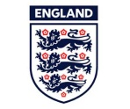 | Three Lions | Three Lion bars | 1
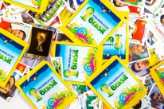 | Panini stickers  Swapsies, anyone? | Panini 2014 stickers showing different individual players from any country (i.e. not the team group photo)  For any 2 players from the same country:  Or for any 3 players from the same country: | 1  2
 | Golden Boot | A golden boot  Be creative! Fabrication is allowed for this one | 1
 | The world | Take a photo of your whole team standing outside any pub which has a country in its name  (the photo must show the country!) | 1
 | Frank Lampard | A stamp that has been franked on its way through the post | 1
 | For teams of 1-4 people: any one of the following  For teams of 5-8 people: any two of the following  For teams of 9+ people: all three of the following  These must be from a newspaper/magazine (internet prints etc. won’t count) |  | 1
 | Joe Hart | A picture of a deer
 | Jack Wilshere | A picture of a sheep
 | Raheem Sterling | A picture of a silver trophy

And the TOP TREASURE:

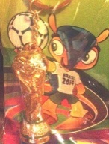 | Jules Rimet trophy | Find this trophy keyring (in its packet) we’ve hidden somewhere along the route and hand in to the marshals when you finish… | 2

Where was the Top Treasure?

The Top treasure was on the walkway between the Slug and Lettuce and the Dickens Inn

Finishing Parade

Each team should parade one team member:
- dressed as a football referee,
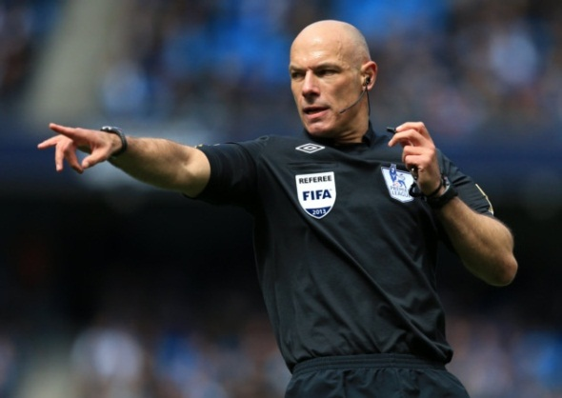
- sending off another team member for a 2nd bookable offence
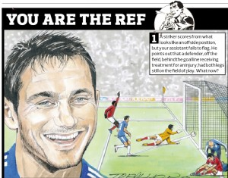
With points for:

- Appropriate referee attire (1pt)
- Wearing multiple watches (1pt)
- Yellow and red cards (1pt)
- Refereeing technique (1pt)

See you on 12th September 2014 for more Hare & Hounds...

